## Registration Date

A new policy for boat rides has been implemented, requiring registration for boat rides 10 days prior to the travel date (DOT).

Write a query to display the ride id,sailor_id and date of registration of all the rides taken by sailors on 'FN' shift, If and only if the month of date_of_registration is 'July'. Give an alias name as 'date_of_registration' for the date of registration of boats.

Sort the records based on the ride id in descending order.

**(Note: Data is case-sensitive.)**

**Sample Data:**

**ride_id         sailor_id    dot**            **shift**

RIDE0107    SA06         2019-08-05    FN  
RIDE0203    SA03         2019-08-02    FN  
RIDE0801    SA01         2019-07-19    FN  
RIDE0109    SA06         2019-09-05    AN

**Sample Output:**

**ride_id         sailor_id    date_of_registration**  
RIDE0107    SA06          2019-07-26  
RIDE0203    SA03          2019-07-23  
RIDE0801    SA01          2019-07-09

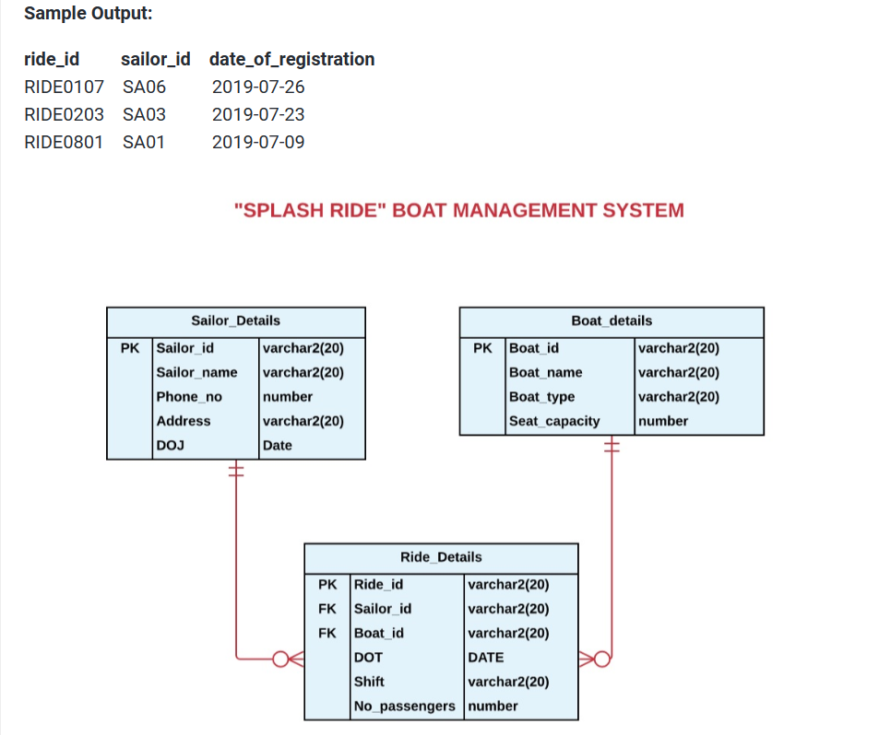

## Policy Information

Write a  query to display the customer name and the number of policies taken by each customer in the format as given in the sample output. Give an alias name as 'POLICY_INFORMATION'.

Sort the results based on the POLICY_INFORMATION in descending order.

**SAMPLE DATA:**

**CUSTOMER NAME**has enrolled **number of policies(policy_id)** policies

**SAMPLE OUTPUT:**

**POLICY_INFORMATION**

**Richard Ford** has enrolled **3** policies

**(HINT: Data is case-sensitive)**

